


Camp & Class Manager
Email Overview FAQ

Camp & Class Manager Email Overview Things to Consider & FAQ

Things to Consider

Times Scheduled/Reminder Email’s and Email Campaign’s send
When an email is scheduled to send at a later date or time, the system will automatically send it in Universal Time Coordinated (UTC time).
Scheduled Example: The database time zone is Eastern Standard Time, (EST) and an email is created and scheduled to send a week later at 4 pm. The system will send it a week later at 11 am UTC.
Reminder Example: All Reminder Emails automatically send at 12 am UTC. To convert this time into your time zone, see the list below.
Please note: Daylight times begin in March/ends in November. Standard begins in November/ends in March.
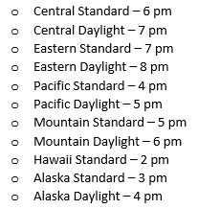
Campaign Example: The database time zone is Central Standard Time (CST) and an Email Campaign with 3 blasts is created. The first blast is scheduled to send a month later at 8 am. The second, 2 months later at 9 am and the third, 3 months later at 10 am. The system will automatically send the first a month later at 2 am UTC, the second, 2 months later at 3 am UTC and the third at 4 am UTC.

Process of Recipient Lists When an Email is Sent
The system has a filtering process when an email is sent.
- Automatically remove emails that have unsubscribed and previously failed/refused to send. (For more details on Failed email click here and for Refused emails click here)

Comparing Failed and Refused Email
The difference is the type of error our servers receive after an email is sent. One is permanent and the other is temporary.
    - Failed emails – Messages rejected due to permanent errors
      - Invalid email addresses for recipient (often caused by typos, which you may be able to fix)
      - Email addresses on a server that was configured to block all emails from the sender's domain
    - Refused emails – Messages rejected due to temporary errors
      - Blocked sender (blacklisted)
      - Full mailbox
      - Temporarily unavailable server
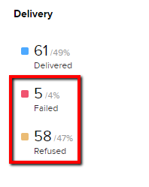
- While an email is Delivering, the system removes duplicated emails.
Example: A family has 2 kids registered for different sessions. If a recipient list includes both sessions; the system will recognize one email address is associated with both kids and will send only one email.
The Sent amount includes duplicated emails and the Delivered amount doesn’t. The Sent and Delivered amounts may not match considering the above information.
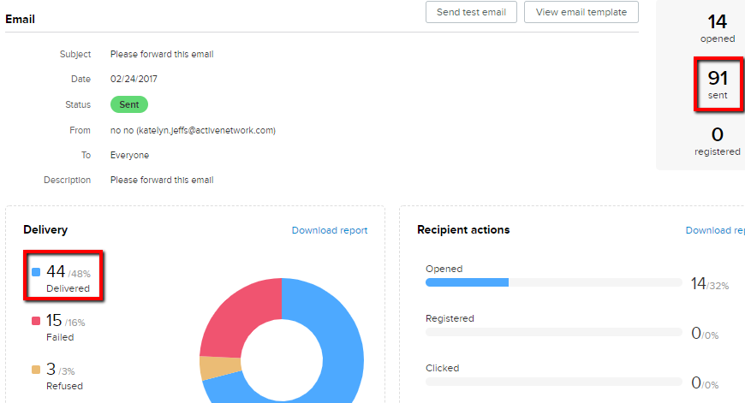

Recipient Actions – Who has Registered through an Email
Is the number of recipients who clicked the Register Now button in the email and completed a registration.
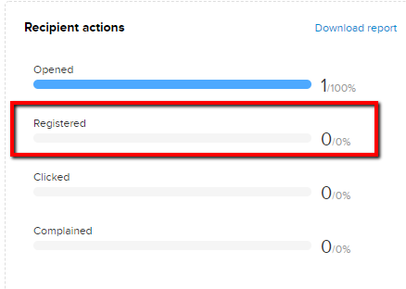
Note: The system only tracks data if Active’s Registration Link merge field is used. Custom buttons and links created won’t be accounted for. It’s located within the Text Box where an email message is created.
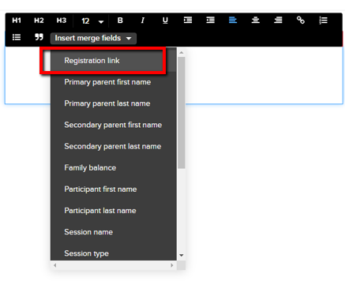

Frequently Asked Questions

Why is my Email Status Processing?
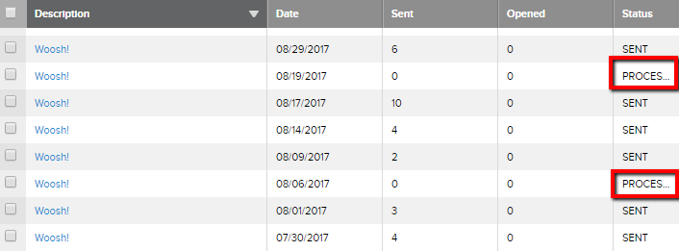
This happens when a dynamic list was created and the Registered For and Not Registered For features were selected. Best practice is to only use one or the other, Not both at the same time. Below is an image of what not to do.
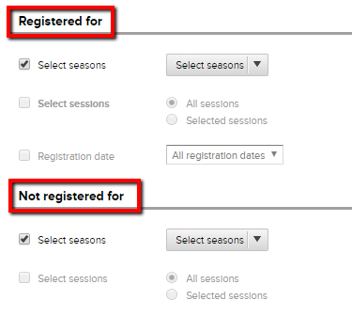

Recipients aren’t receiving my emails
Active sends emails on behalf of your organization. Consider the information below.
- First, ensure emails are delivered properly by adding to your SPF record. Click here for an article for information.
- Your email hosting server may have black-listed Active.com domain. Have your IT include the following Active server names in your SPF record.
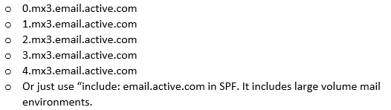
- Yahoo and AOL email addresses shouldn’t be used as your database email. These email providers will block recipients from receiving email communication from you. Click here for a Yahoo article and here for AOL.
- Another reason could be the recipient has unsubscribed. Contact Support to verify if the participants email is on our unsubscribed list. If they desire to re-subscribe submit a request to Support.
- Have recipient check their Junk/Spam inbox.
Note: Have the participant white-list/mark email safe.

Can I cancel an email after I click Send?
Once an email is sent, there isn’t a way to stop it from sending. Please send test emails and double check recipient list(s) before an email is sent.

Can I send emails to people who haven’t registered?
Yes. You can create an Imported List. Click here for an article with steps.

Customer’s receiving multiple emails?
A customer can receive multiple emails if more than one recipient list is used. The system automatically removes duplicate emails when one recipient list is used but, not when multiple recipient lists are used.
Example: If one recipient list is used and an email address is associated with more than one participant, the system will only send one email for all associated participants.
Example: If 3 recipient lists are used and an email is included in all 3 lists, the system will send 3 emails to the same email address.

Why is the “From Email” showing as “Noreply@active.com”?
Active sends emails on behalf of your organization. For best delivery outcomes, the “From Address” displays as Noreply@active.com. Participant replies will go to your organization, not Active.
Contact Support and request a DKIM key, if you would like your organization’s email to display rather than noreply@activenetwork.com.
Below are steps that need to be completed after a DKIM key is requested.
  - Configure DKIM key (Completed by your IT/Webmaster).
  - Confirm with Support key has been configured.
  - Validate the configuration. (Completed by Active)
The change will take effect immediately after the key has been successfully validated by Active.

How can I check who I sent an email to (Recipient List)?
Dynamic List(s) can be checked if the list was saved for future uses. Make sure the box in the below image is checked when a Dynamic list is created.
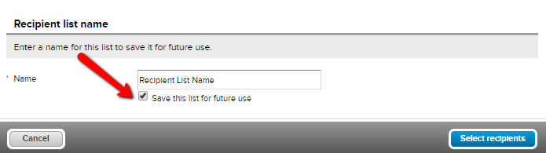
Follow the steps below to check settings of a saved Dynamic List
- Click Email tab
- Click Sent
- Locate and click on desired email name
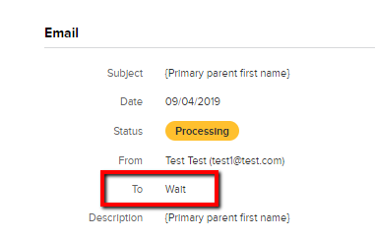
- Note the list name beside TO
- Click Email
- Select New dropdown
- Select New Email
- Click Ok
- Click Add Recipient Lists
- Click on desired list name
- Check the list criteria
If you’re wanting specific emails included in a Dynamic/Imported list, contact Support.

