


Camp & Class Manager
Email Overview

Camp & Class Manager Email Overview

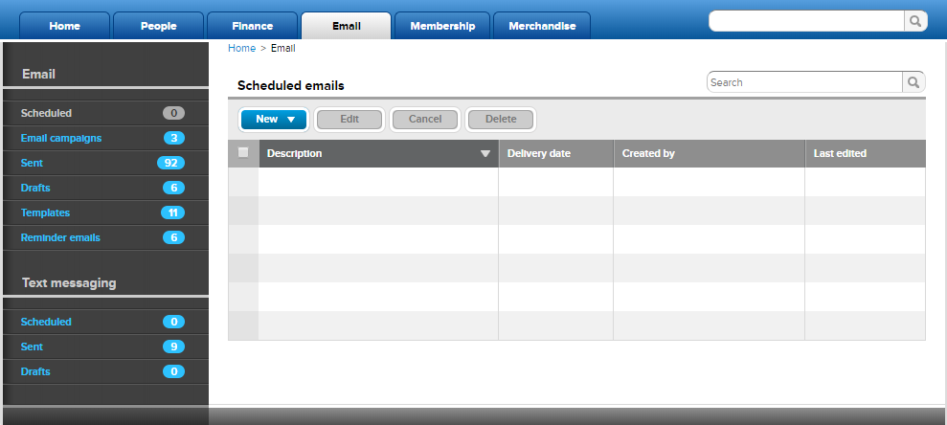
- Scheduled - Create a new email and schedule to send it to customers at a later day and/or time.
  - Emails are scheduled on the Preview & Send page under Delivery Schedule by selecting Send this email on a specific date and time.
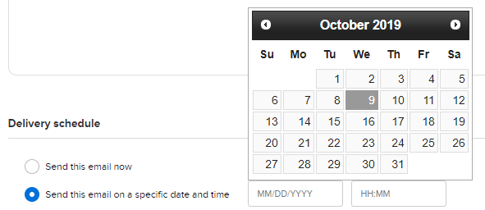
  - After an email is scheduled, it will be listed in the Scheduled tab.
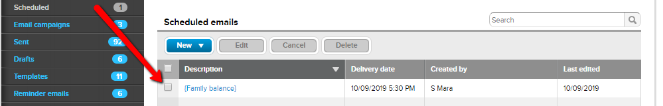
  - You can Edit, Cancel or Delete a Scheduled email.
    - Edit - Edit Email Information, Design and Delivery Schedule.
    - Cancel - Cancels the email from sending on the scheduled date/time. The email will appear in the Drafts tab.
    - Delete - Permanently delete scheduled email out of the system.
  - It appears in the Sent tab after it sends.
- Email Campaigns - Create an email campaign to send a series of emails that can be tracked together.
  - Basic Information – Specify a name and a description (optional) for the campaign. This is for your organization and will not be seen by your customers.

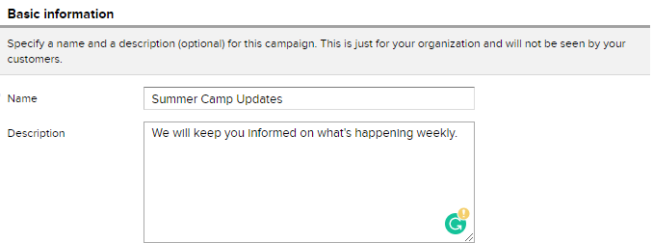

  - Emails in this Campaign - Configure up to twenty individual email blasts.
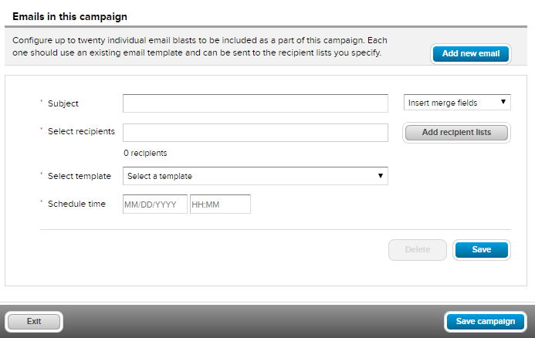
    - Create template(s) for blasts before creating campaign.
    - Include multiple recipient lists
    - Option to edit or Delete individual email blasts.
  - View Past and Current Campaigns.
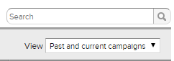
  - View Report - Shows data and list of included email blasts.
    - Date Range – Date range that includes all email blasts.
    - Total Reach – Total of selected recipients.
    - Sent – Total recipients the system sent an email to after removing duplicates, unsubscribed and blocked emails. The Sent amount can be less than the Total Reach amount.
    - Opened - Total recipients who opened an email. Click here for more info.
    - Registered - Total recipients who completed a registration. Click here for more information
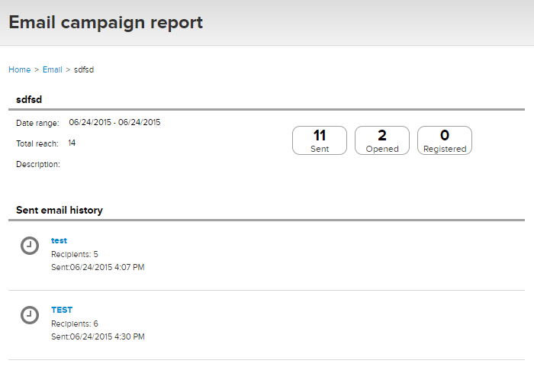
- Sent Email History – View email blast report(s) individually by clicking on the name.
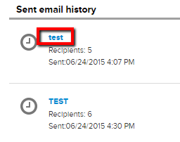
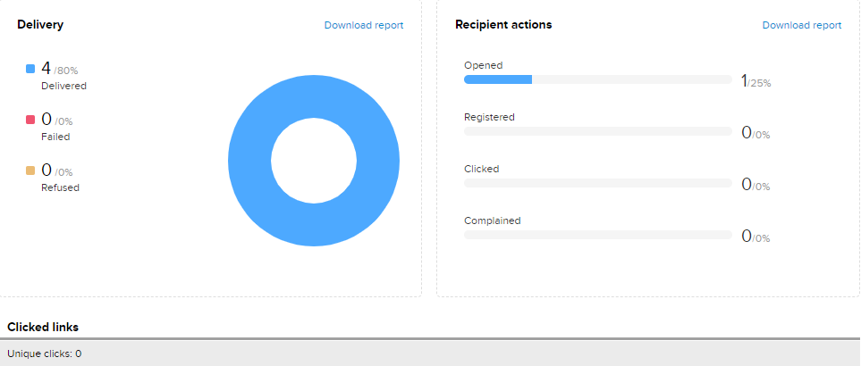
- Sent - Lists all emails sent from the Email tab.
  - Doesn’t include direct emails sent in family accounts.
  - View report of email(s).
- Drafts - List of emails waiting for an action.
  - Type of Action -
    - Delete permanently
    - Edit Email Information
    - Edit Design
    - Save as Template
    - Schedule Email
    - Send Email Now
- Templates - List of preset email formats created to be used at any time.
  - Edit Template Information and Design.

- Reminder Emails - Create a reminder email to send to registrants at midnight (UTC not your local time zone) on a specified delivery schedule.
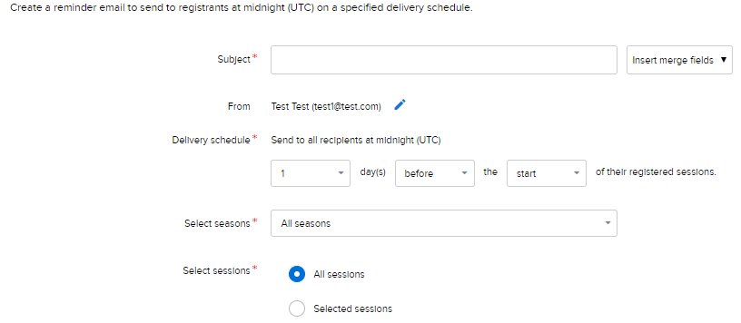
Specific Delivery Schedule
  - Can be sent before/after a season/session starts or ends.
  - Email Reminders are only sent to recipients who are currently registered.

- New Email – Create an email for recipients from your database or an imported list.
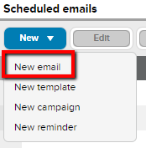
Create a new email or use an existing template.
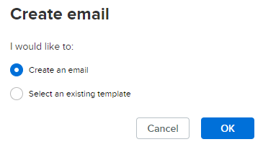
  - Email Information
    - Subject -Type in subject and/or select a merge field.
      - Insert Merge Fields - Use account level merge fields for feature to work properly.
Example: primary parent, secondary parent and family Balance.
    - Recipients - Who you want to send the email to.
      - Dynamic list – Participants who have registered. Click here for an article on creating/edit a dynamic list.
Note: Secondary parents can be included by checking the below box.
      - Imported list – Participants not who haven’t registered through the system. Click here for an article with steps to import a recipient list.
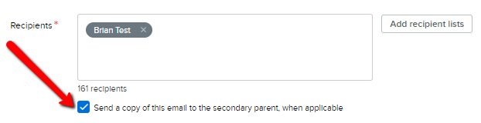
    - Description - For internal reference only, email recipients will not see this description.

  - Design - Drag and drop items from the sidebar and move them to the left.
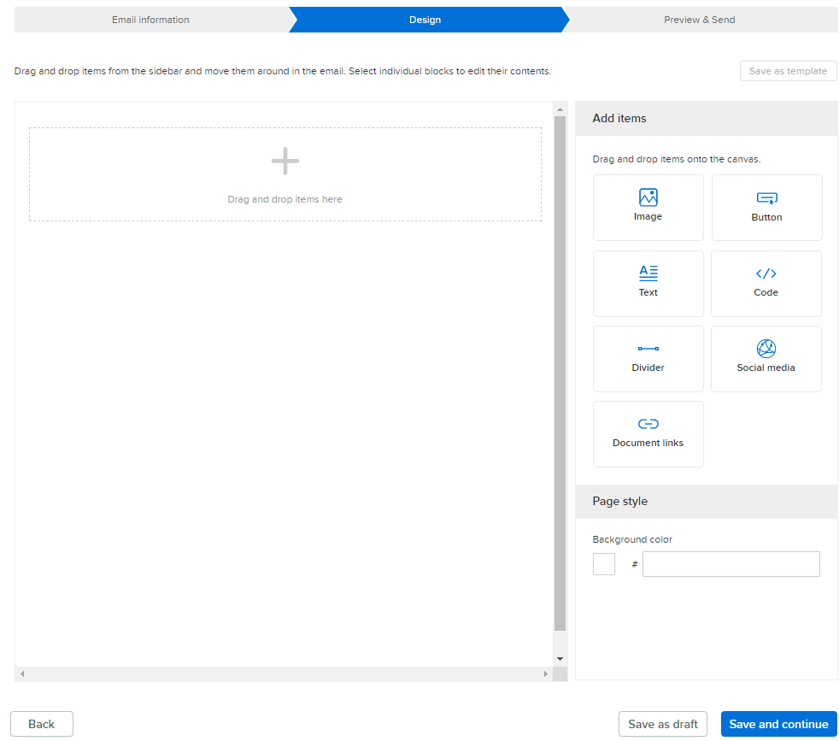
    - Page Style - Select a background color (optional).
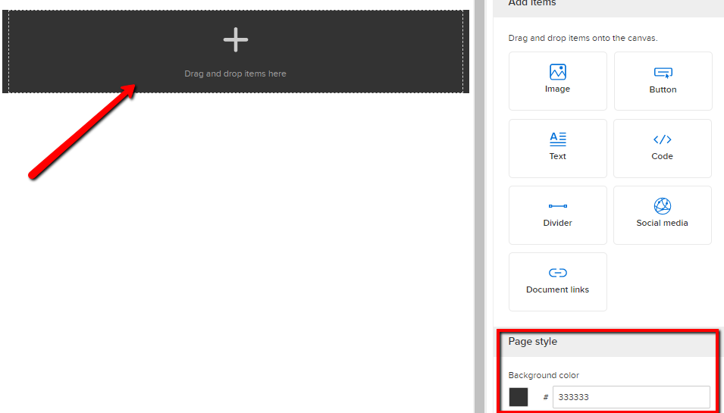
    - Image - Add an Image as a header or footer to advertise and/or hyperlink a webpage.
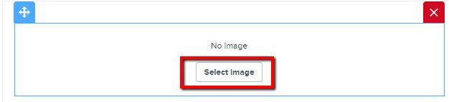
      - Select a default image or upload a custom image.
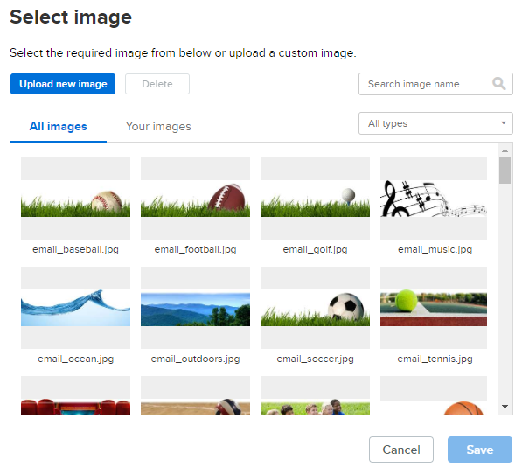
        - Upload New Image – Upload saved image from computer and select Footer, Header, Logo, Background or Merchandise.
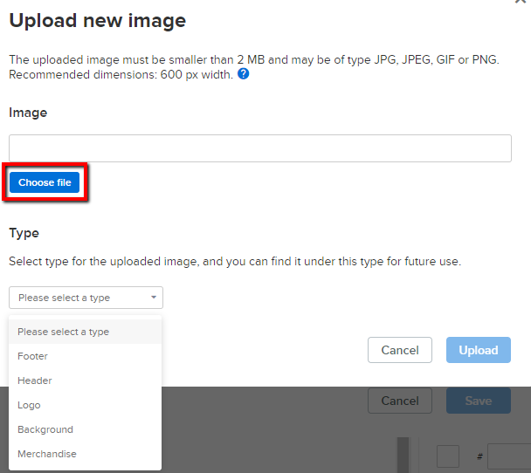

      - Image must be smaller than 2 MB.
      - Image type can be JPG, JPEG, GIF or PNG.
      - Recommended dimension is 600 px width.
      - Hyperlink images for recipients to click.
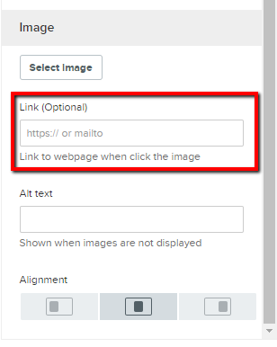
    - Button - Hyperlink a customized button for recipients to click.
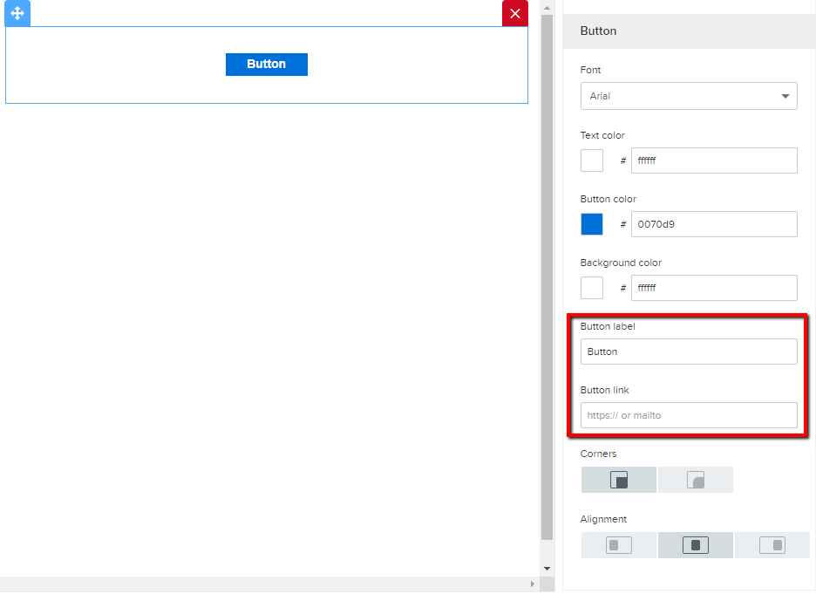
    - Text - Add message and customize it for your recipients.
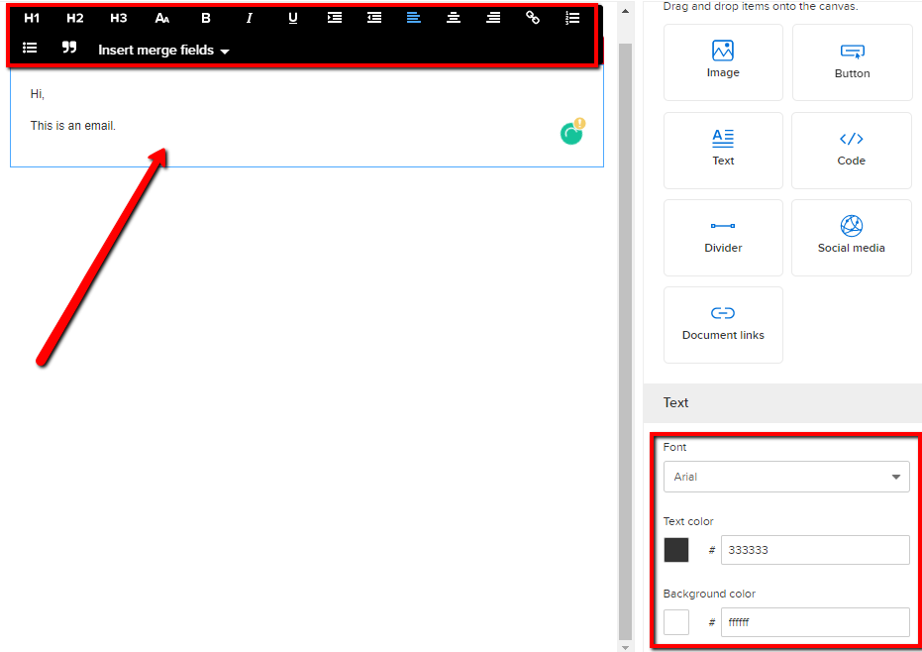
    - Code – Add HTML/ Inline CSS to your email.
Note: Support is unable to assist with coding.
    - Divider – Creates a line that divides sections.
      - Customize the space between the lines padding, color and width.
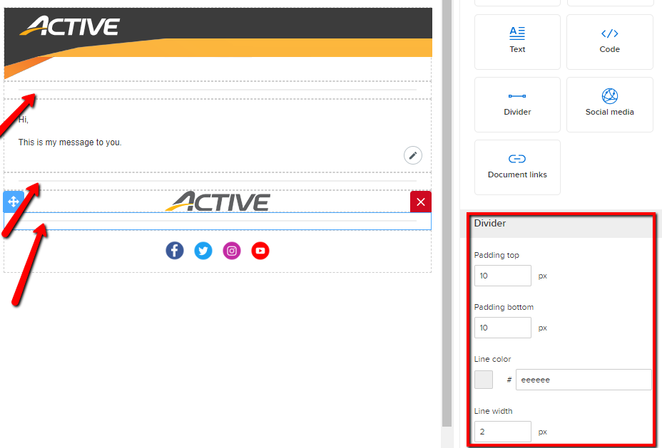
      - Padding – Space between the divider and sections.
    - Social Media – Insert organization’s social media URLs for recipients to access.
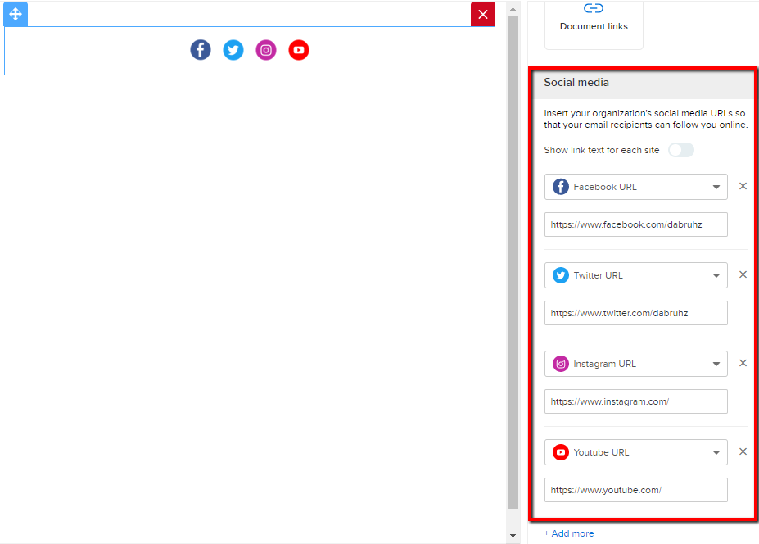
    - Document Links - Add attachments to include in email. The attachments will be shown as hyperlink texts. Click here for info about Active’s File Upload Policy.
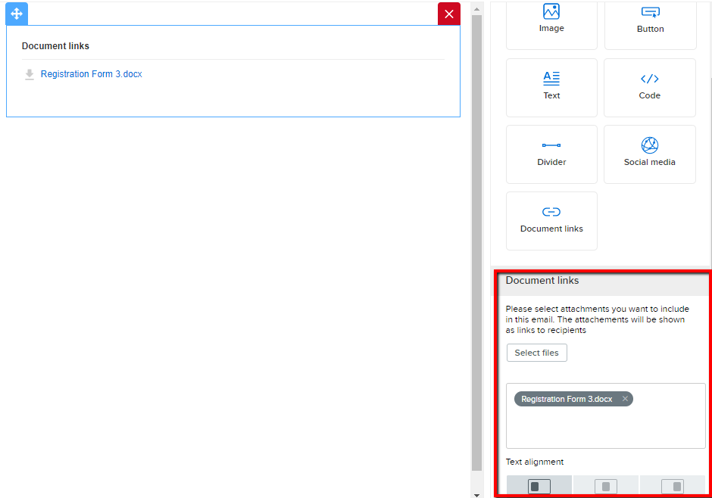
  - Preview & Send - Preview your email on both desktop and mobile devices before sending.
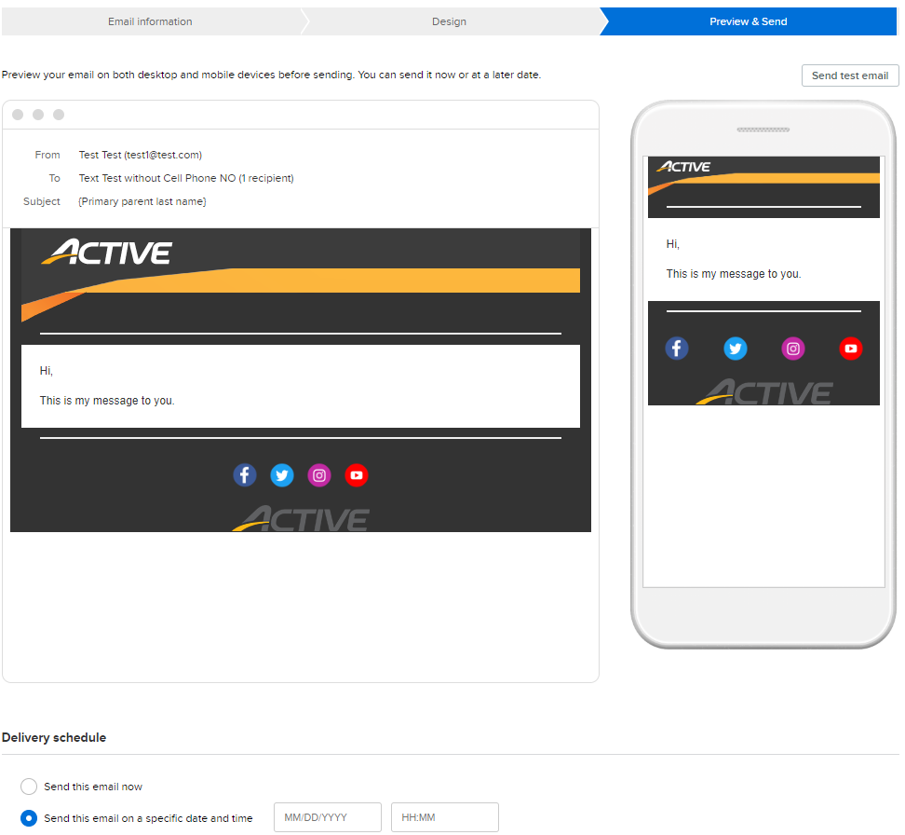
    - Send Test Email - Make sure emails appear and function properly by sending it to up to 5 different email addresses.
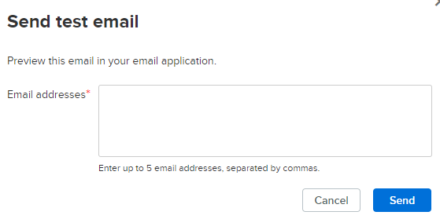
    - Save as Draft - Save your work and return to it later.
    - Delivery Schedule - Send email immediately or schedule it to send later.
- Email Report
Tracks email performance.
  - Opened – Number of emails opened by recipients.
  - Sent – Valid email addresses (including duplicate addresses) the email was sent to.
  - Registered – Number of recipients who clicked, Register Now button in the email and completed a registration.
Note: The register Now button is in the Text module: Insert Merge Fields.
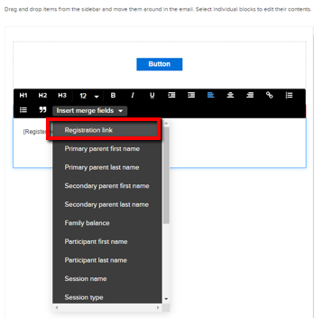
Delivery
- Delivered - Number of unique and valid email addresses to which the message has been delivered.
- Failed – Message rejected due to permanent errors, such as incorrect email addresses (often caused by typos, which you may be able to fix). Click here for more info.
- Refused – Message rejected due to temporary errors, such as a blocked sender, a full mailbox, or a temporarily unavailable server. Click here for more info.
Recipient Actions
- Opened - Estimated number of emails opened by recipients. Click here for more info.
- Registered - Number of recipients who clicked the Register Now Button in the email and completed a registration. Click here for more info.
- Clicked - Number of unique recipients who clicked at least one link in the email.
- Complained - Number or emails marked as junk mail. Click here for more info.

- Text Messaging - Send a Text Message to the provided parent/guardian cell phone number.
- This feature must be enabled before use. Contact your Account Manager to enable.
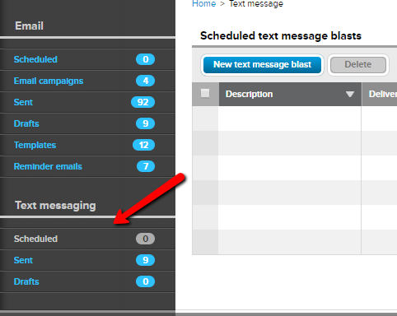
  - Scheduled -Text messages scheduled for a future date and time.
  - Sent - All text messages sent from the database.
  - Drafts - Text messages saved as a draft.
  - Start a New Text Message Blast by clicking Scheduled
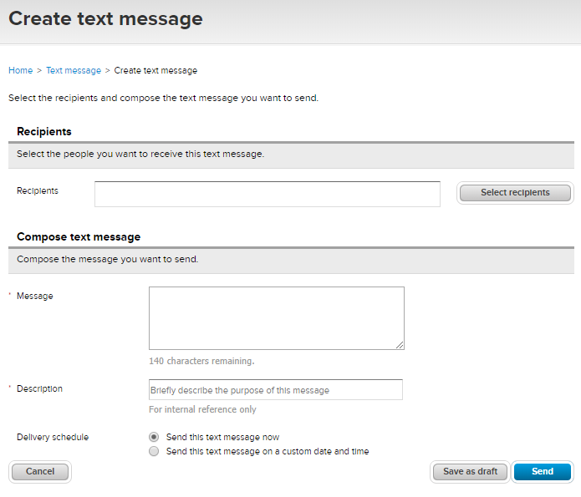
- Recipients - Recipients must have answered the Active’s default Cell Phone question in the Parent/Guardian section on the registration form. Creating a custom cell phone question will not work. The Active Cell Phone question must be used.
- Imported Lists can’t be used.
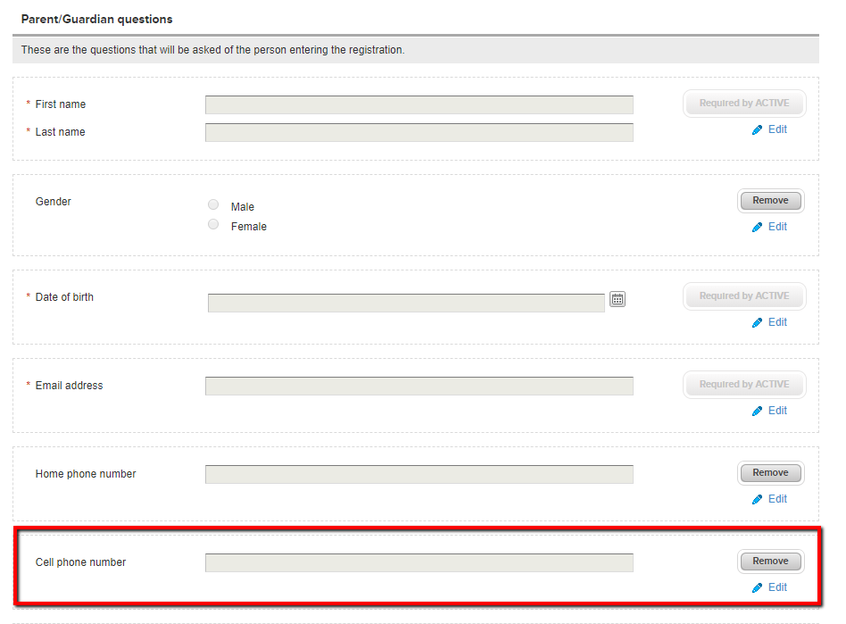
- Message - up to 140 characters
- Description - For internal use only.
- Delivery Schedule – Send a text immediately or schedule for a later date and time.
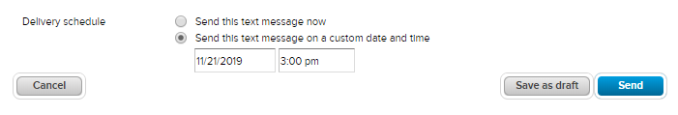
- You will need to click Send when scheduling a text to send later.
- Text messages can’t be canceled once it’s sent.
- Delivery Status
  - Date and time a text was sent
  - To: Recipient List
  - Description: Only displays if a description was entered
  - Message: Text message recipients received.

