


Camp & Class Manager Season Reports Overview

Camp & Class Manager Season Reports

Pre-created Reports
Pre-created reports are created by Active with a preset format. Access these reports by clicking Reports under the desired season.
- Cart Abandonment e-mail report - Shows records of all incomplete registrations in the last 90 days.
  - Enable this feature by contacting your Account Manager.
  - The system will start reporting on abandoned registrations once the feature is enabled.
  - The report can be filtered by Session, Date Range and if they registered at a later time.

- Daily Attendance Report - Shows the daily attendance records for all your registrants.
  - This feature must be enabled by Active Support, then turned on in Step 1 of Season Setup.
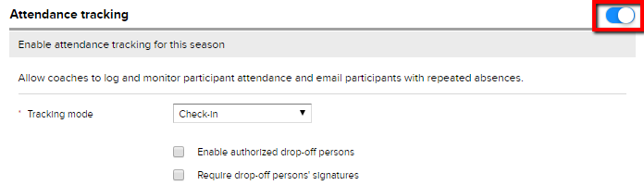
  - Steps to Reproduce
    - Click Setup under desired season.
    - To the right of the screen, select Season.
    - Click on the grayed out white circle.
    - Click Save and Continue
  - Reports on participant attendance per session.
  - Filter by Session, Tuition and Session date.
  - Click here for more information.

- Merchandise Purchase Report - Shows the current merchandise purchases for all sessions in your season.
  - Filter report by Merchandise, Session and Date of Purchase.
  - Doesn’t include merchandise from canceled orders.
  - Click here for more information.

- Participant Notes Report - Shows notes for all registrants.
  - Filter report by Type of note, Creation Date and Last Edit Date.
  - Includes which user created or edited note.
  - Click here for more information.

- Session Capacity Report - Shows the current registration capacity for all sessions in your season.
  - Click the session name and the system will take you to the Sessions Dashboard for an overview.
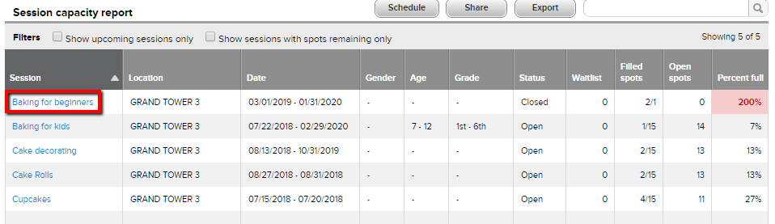
  - Filter by upcoming session and/or sessions with remaining Spots.
  - Click here for an article with steps.

- Waitlist Report - Shows a list of waitlist registrations for entire season
  - Filter by session(s), date and tuition
  - Click here for steps to run this report.
Pre-created Report Functions
- Schedule- Schedule automated report deliveries, allowing system users to receive reports on a regular basis, by email, without logging into the database. Click here for a User Guide.
- Share – Ability to email a report as an attachment or link.
- Email Selected People – Email participants listed in a report.
  - Check boxes of desired recipients or email everyone listed by checking the first box under Email Selected people. The email will go to the primary parent.
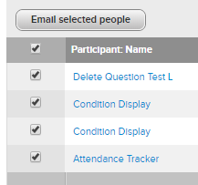

Pre-Created PDF Reports
Are only downloaded as a PDF report and cannot be customized.
- Check-in Report - A printable participant list for use at check-in.
  - Includes notes, group assignments, session options/merchandise and waivers/supplements & follow-up forms.
  - Filter by session(s).
  - Click here for more information.

- Registration Form Report - A printable copy of completed participant registration forms.
  - Option to include or exclude supplemental Forms, waivers, authorized pickup and registration form questions in report.
  - If Waivers are included the system will display signatures in the report.
  - Filter by Session.
  - Click here for more information.

- Waitlist and Session Registration History - A printable record of all waitlist and session registration activity.
  - Lists how a participant is registered and if there have been any registration adjustments.
  - Filter by Session.

New Custom Report
Create a report and choose what data is included.
View of Custom Report in Database
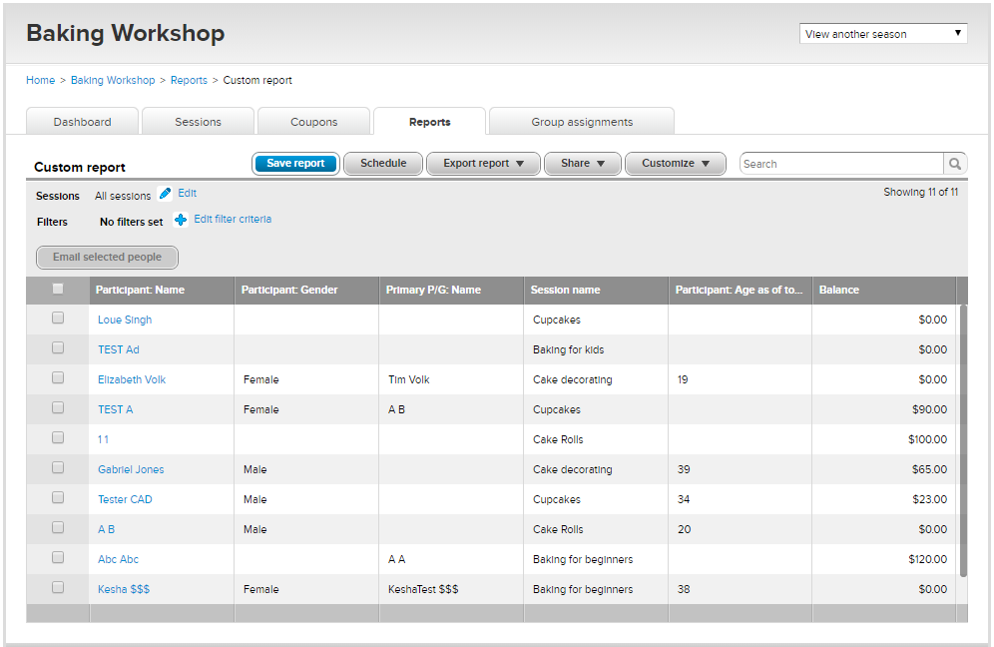
- Customize - The Customize tab is where most of the report is customized.
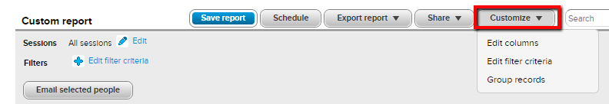
  - Edit Columns – Select columns to choose what data you want to include in your report.
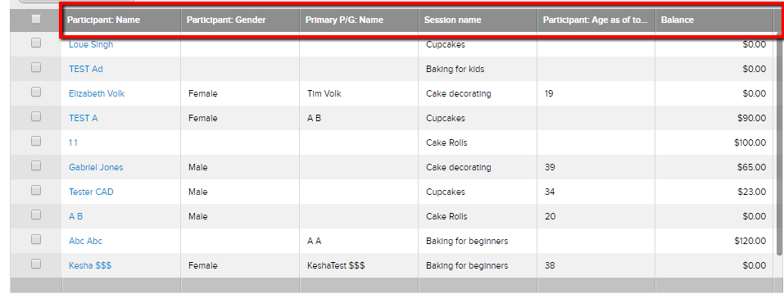
    - Selected Columns – Columns currently included in a report.
      - Remove columns from the report by checking desired box(s) and click the arrow pointing to the left.
    - Available Columns – Are optional columns available to include in a report.
      - Add columns to a report by checking desired boxes and click the arrow pointing to the right.
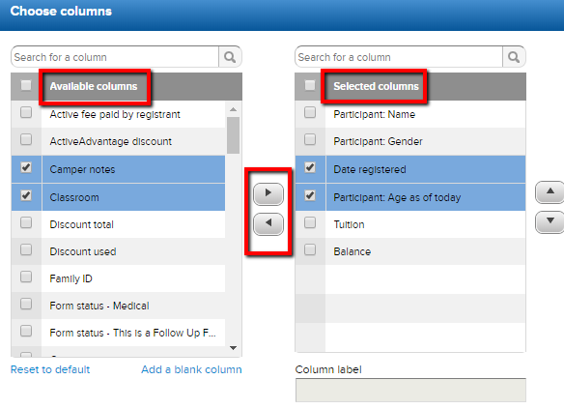
    - Add a Blank Column – Creates a column in a report but won’t pull data from the system.
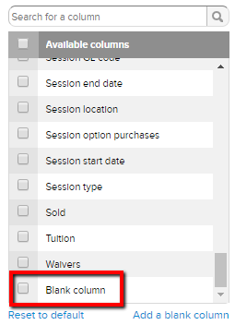
      - Automatically goes to the bottom of the Available Columns list.
      - After adding a blank column make sure you move it to the Selected column side. (right column)
      - Check the Blank Column box and click Column Label field, to name your column.
      - This column is usually used after a report has been printed for organizational use.
    - Column Label – Renames your columns.
      - You can always change the label name back.
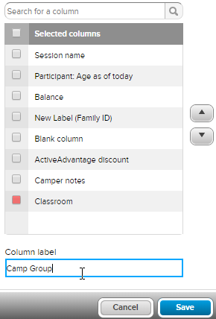
  - Edit Filter Criteria – Apply filters to your report.
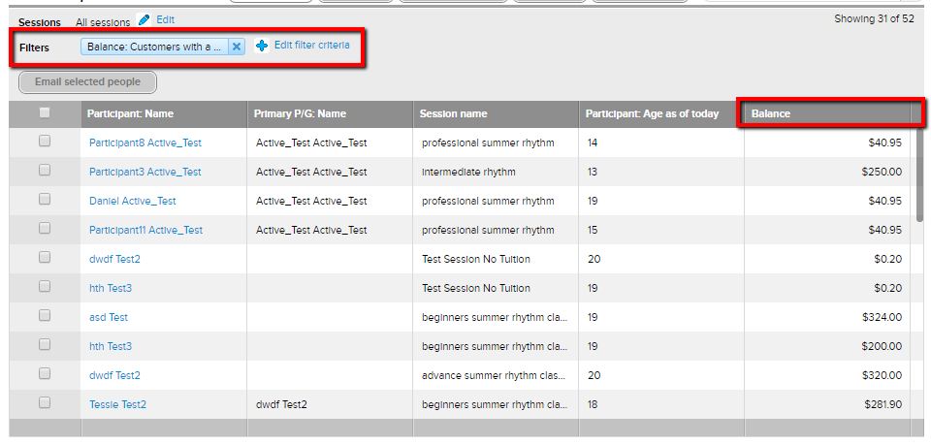
  - Group Records - Select information you would like to group records by.
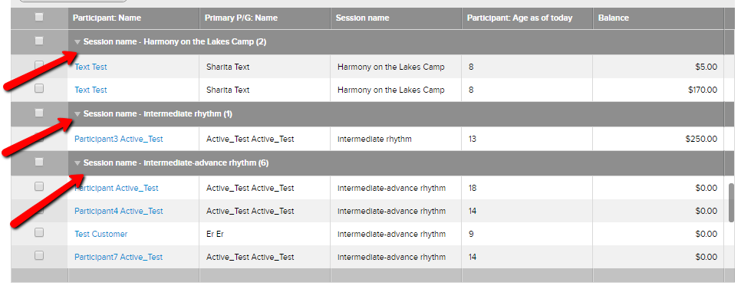
  - Filter report by session.
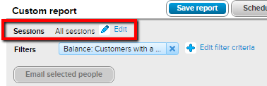
  - Filter by session, Edit Filter Criteria and Group Records at the same time.

- Save Report – Save reports for future use.
    - Saved Custom Reports are located at the end of listed reports. 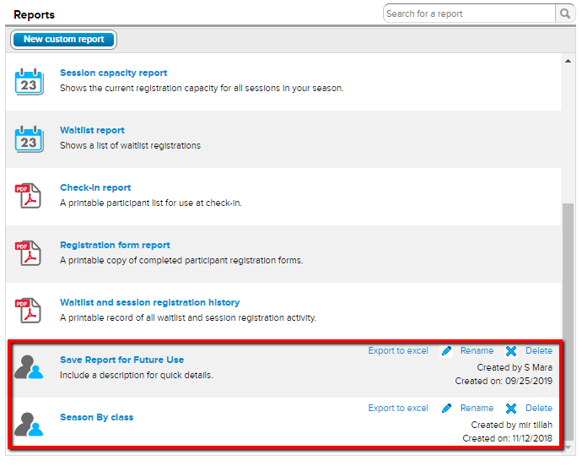
Types of Custom Reports - Below are types of custom reports that are commonly created.
- Age Report - Report on the ages of your participants
- Contact list - Create a report with participant contact info (phone, email, address)
- Discount report - Report on discount totals and who has received a discount.
- Balance Report - Report on season balances.
- Click here for an user guide and here foe an article with steps to create a Custom Report.

Frequently Asked Questions

I don’t see my report, where is it being exported?
- Google Chrome - Is the recommended browser for Camps & Class Manager. Reports export to the bottom left side of your screen, above the Taskbar.
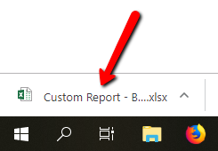
- Mozilla Firefox - Typically Firefox will display a pop-up box, asking which program you want to use to open the report. The
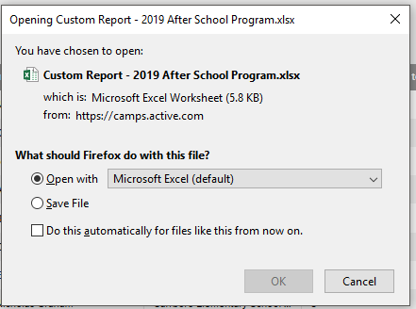
- Internet Explorer/Microsoft Edge – Will export reports to the bottom center of your screen, above the Taskbar.
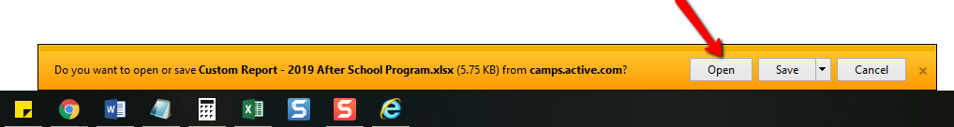
- Safari – Reports are exported to the upper right corner, next to the URL bar.
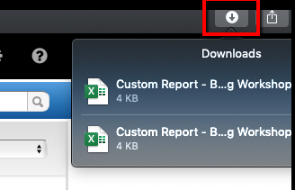
- If you still can’t locate the report, try steps in this article to check your pop-up blockers and cache/cookies.
- Contact Support if you continue to have problems.

How can I export a report for multiple seasons?
- Cross-Season Reporting groups participant info on attributes such as age, gender or registered seasons and sessions.
- Reports only on participant information.
- Click here for more information on Cross-Season Reporting.

Why are some fields blank in my report?
Consider the below information
- Fields could be blank because the question wasn’t required. Participants can complete a registration without answering questions that aren’t required. Click here for an article with steps to check if the question is required.
- When a question is removed from the registration form the system will exclude those answers from a report. Click here for an article with steps to add the question back to the form to report on it. You can make the question internal while reporting. Click here for an article with steps. After you’re done reporting, remove the question from the registration form. Click here for steps to remove question.
- Contact Support if you’re still needing help.

Why are participant names appearing multiple times?
- Participant names will appear more than once if they’re registered for more than one session. This is by design.
- Example: John is registered for Session 1, Session 2 and Session 3. John will display 3 times for each session.

How can I report on signed waivers?
- The Registration Form Report provides waiver signatures, date and time waiver was received. Click here for an article.
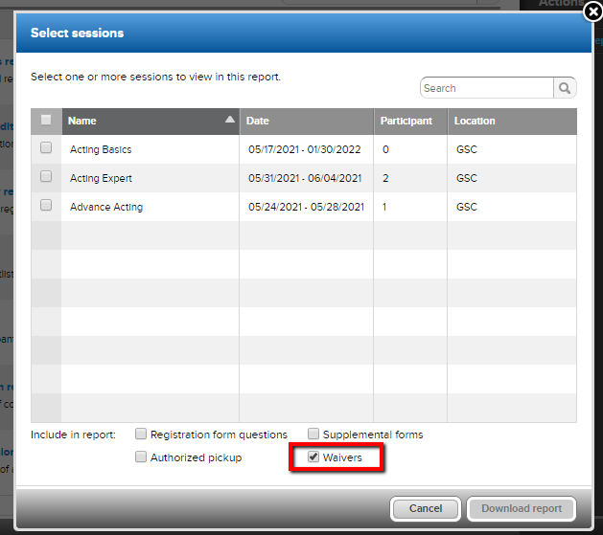
Custom Report is another way. Customize your columns to include the Waivers column. It will display if the waiver has been received or not.
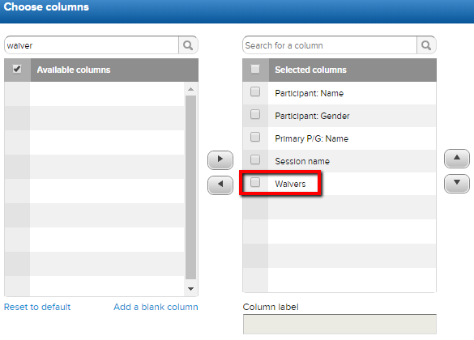
  - Signed waivers will be marked as Received. Waivers that haven’t been signed will appear blank.
  - To create a Custom Report for Waivers, follow the steps below.
    - Click season name on Home screen
    - Click Reports tab
    - Under Reports Select Registration Form Report
    - Select desire Sessions
    - Next to Include in Report: check Waivers box
    - Click Download Report

How do I export on Supplemental/Follow-Up Forms?
Follow the steps below.
- Supplemental Forms tab
  - Click on season name from Home screen
  - Select Supplemental Forms tab
  - (optional) Select desired Sessions, Form name, Type and Status and, Filters
    - Statuses - Supplemental Forms: Received/Not Received and Follow-Up Forms: Completed/Not Completed.
  - Click Export
    - Download Forms – Participant Supplemental forms can be downloaded. Follow-up forms can’t. Click here for an article with steps.
- Registration Form Report – Select Supplemental Forms to Include in Report. Click here for an article with steps.
