Program Setup: Thriva to CCM

Programs are created within a season.
Click Create a season from the Home page.
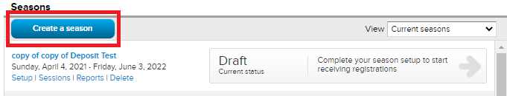
There are 9 steps in the season setup process. Create/edit programs in Sessions Step 2.
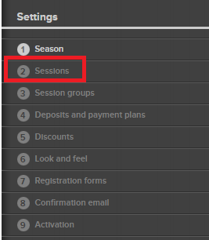
Click here for help to create a session.
To edit a season/program after it’s created, click Setup from the Home screen under desired season.
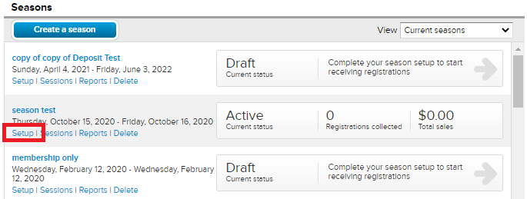
To view past seasons, click the View dropdown option and select Past and Current Seasons.
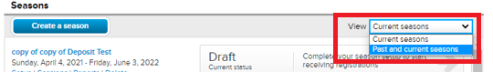
Note: Confirmation emails are created and managed from Season Setup Step 8. Click here for an article.
Click here for additional information on creating a season.

Financial Options: Thriva to CCM

In CCM Financial Options are broken into the 4 options listed below. Click the name of the option for more information.
- Tuition
- Session Option
- Global Session Options
- Merchandise

Note: Global Session Options are like Financial Options. Once created you can assign it to any program in any season. Session Options are created in one specific program and cannot be assigned in other seasons or programs.

Tuition and Session Options are created in season setup step 2, Sessions.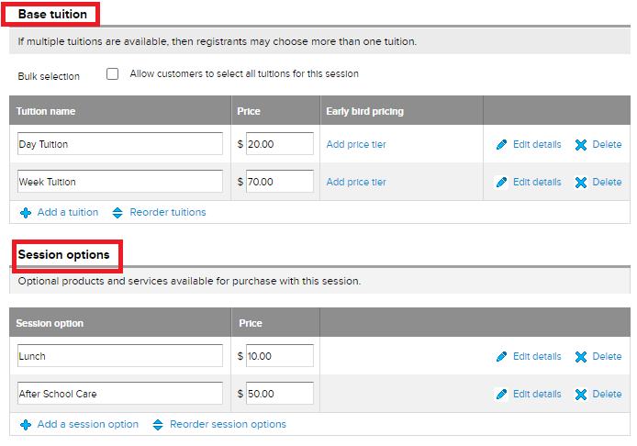
Global Session Options and Merchandise are created in the Add-ons tab.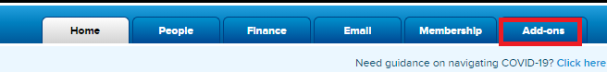
Note: Once Global Session Options and Merchandise are created assign/associate the items with desired sessions in season setup step 2, Sessions.
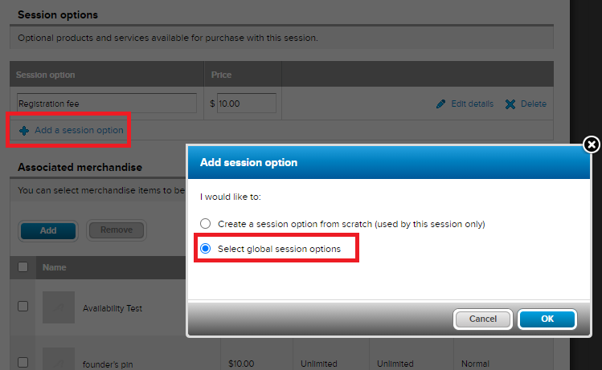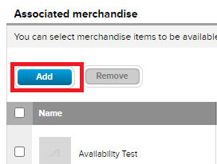
Click here for steps to associate merchandise and here for adding a Global Session Option.

Form Builder: Thriva to CCM

The registration form is customized in Season Setup step 7, Registration Forms.
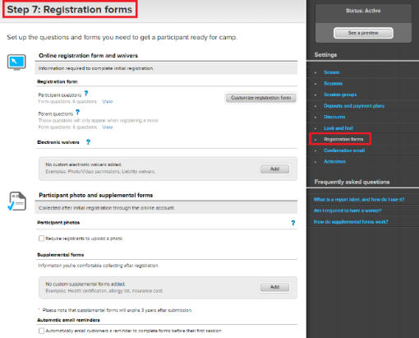
Create or customize the below registration form features. Click on name for more information.
- Registration Form Questions
- Electronic Waivers
- Participant photo: Participant uploads after registration through participant’s online account or upload for participant through database.
- Supplemental/Follow up Forms: Completed after registration through participant’s online account.
- Automatic Email Reminders: The system will automatically send an email to remind participant to complete Supplemental/Follow-up forms.

Customize the Look and Feel of the registration form in season setup step 6 or Account Settings.
- Add a Logo/Image
- Color customize
- Form Header
- Background Image
Check registration form by clicking See a Preview.
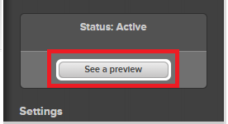
Note: Completing a registration in See a Preview will not create a real registration. A test credit card is not available. If a real credit card is used it will not create a transaction.
Data Center: Thriva to CCM

In CCM family accounts are located in the People tab.
Click People tab from the Home screen.
Note: You can search by participant/parent name or email address.
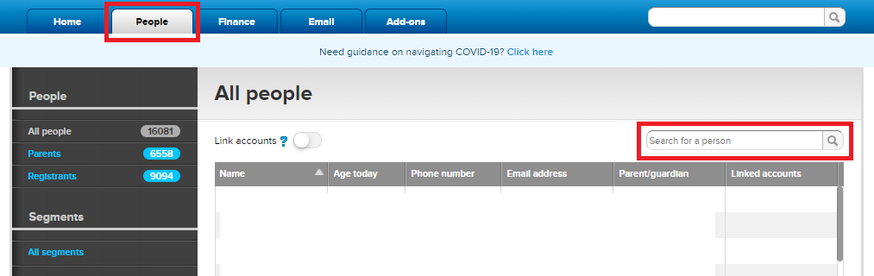

Family Account Features. Click feature name below for more information.
- Manage registration
  - View Order/Transaction History
  - View/Edit Registration Answers
  - Edit Purchase
  - Transfer participant
  - Add Discount or Coupon Code
  - Partial refund
  - Cancel registration

- Update contact info
- Complete internal registration
- Download Financial Statement
Note: other reports are not available in participant account.
- Add notes
- Send Email
- View Email History
- Make a payment

Accounts can be linked but cannot be merged. For more information on linking accounts click here.

Report Center: Thriva to CCM

Reports in CCM are broken out into Seasonal reports and Financial reports.
- Seasonal Reports – Reports on participant-registration related data. Are located within a season.
- Click Reports under season name from Home screen.
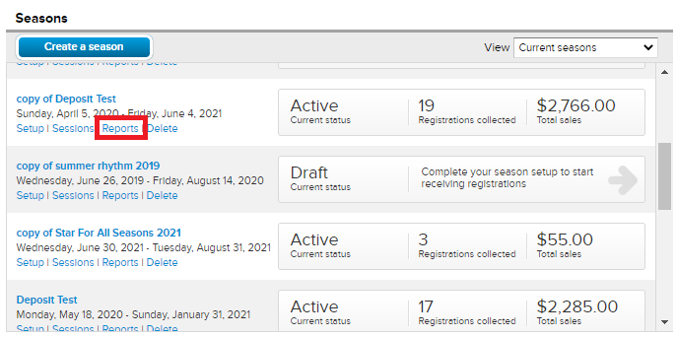
For more detailed information on season reports click here for an overview & FAQ.

- Finance Reports – Reports on financial data across seasons. Are located within the Finance tab.
- Click Finance tab from Home screen
- Click Reports tab
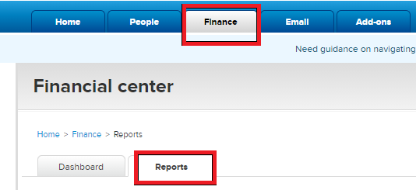
For more detailed information on finance reports click here for an overview & FAQ.
Note: The Active Account Statement in CCM is equivalent to Financial Statements in Thriva.

- Other reports – Click report name below for more information.
Note: These reports do not pull financial data.
  - Segment Reports – Reports on only demographic data across seasons.
  - Cross-Season Reports – Export data through a Custom Report across seasons.
  - Fulfillment Report – Report on sold items that have delivered or need to be delivered across seasons.
  - Session Option Purchase Report – Report on the amount of session options sold across seasons.

Communication Center: Thriva to CCM

In CCM the Email tab is the new Communication Center. Send mass emails or a direct email to participants.
- Mass Email: Send an email to all registered participants or a specific group.
Click Email tab from the Home screen.
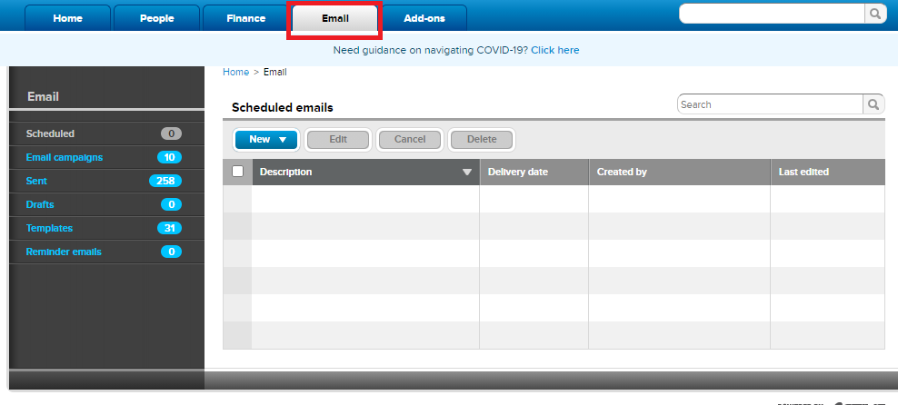
- Email from Family Account: Send a direct email to a participant from their family account.
  - Click People tab
  - In search bar locate and click desired name
  - Click Send Email
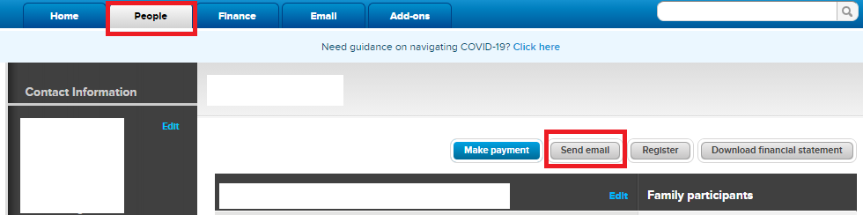
- Email from Reports: Email selected group directly from a report.
  - Check box next to Participant Name column or select desired names
  - Click Email Selected People
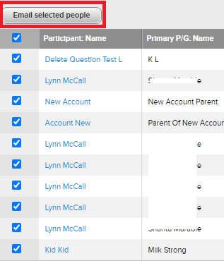
Note: Confirmation emails are created and managed from Season Setup Step 8. Click here for an article.
For more information on emailing click here for a detailed overview & FAQ.

