



Group Assignments

CCM Group Assignments

Group Assignments can be very useful for assigning specific participants to unique groups. This can be especially useful for camp cabin assignments, sports team assignments, or skill level assignments. Click here for more information and here to access.

Group Type

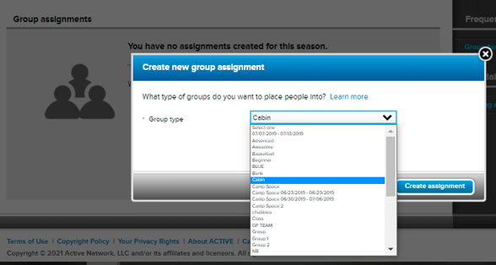

Allows you to distinguish between multiple Group Assignments associated with a program or a participant.

Example a participant can be in a Cabin group type, and a Team group type for the same program.

When you create a new group assignment, the first thing you will be asked is what type of assignment you wish to create. You can choose from a number of pre-created options like cabins, and teams, and classes, or you can create your own custom group types. The term for the type of group that you choose will show up in association with that group assignment when you manage that group throughout the system.

- Manage Group Assignment - Group Assignment Setup

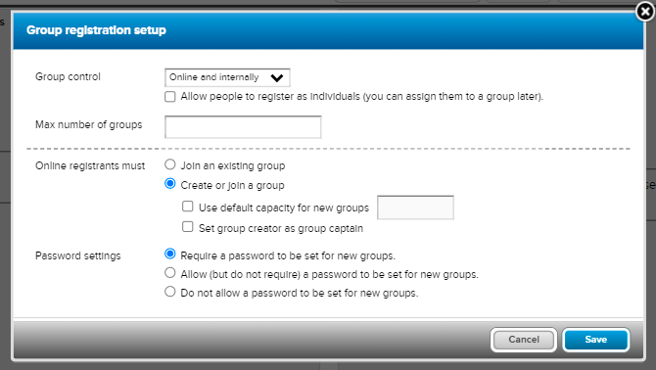

- Group Control – Choose if you want Group Assignments to display during online registration or kept internal for admin use.

Note: If kept internal b-d is not applicable.

- Max number Groups – Set a limit to how many groups participants can create during online registration.
- Online Registration Must – Allow participants to join an existing group (created internally) or create their own group and/or join an existing group.
- Password Settings – Options to require a password, allow but not require a password or no password requirements for new groups.

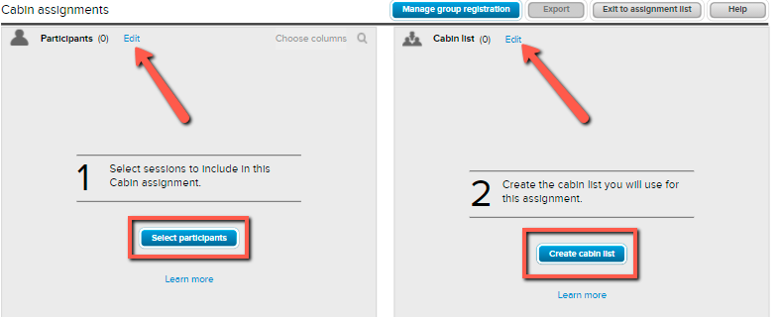

- Participants/Sessions (1) –
Click Select Participants or Edit next to Participants to select sessions the Group Assignment will be applicable to.

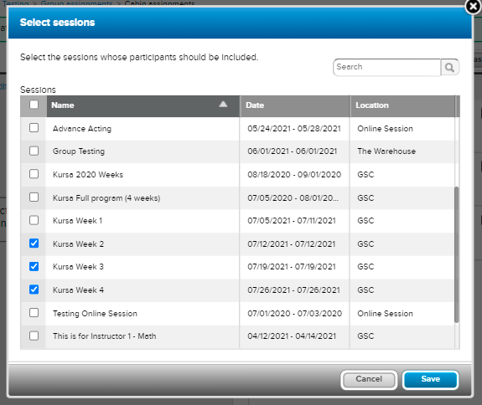

- Group Assignment List (2) – Click Create List or Edit next to list name to create list(s) admins will use to assign participants.
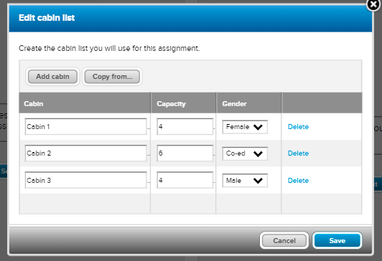
Note: Skip if you only want your participants to create lists.
Note: The above note is recommended if participants are familiar with this feature.
After a list is created, it’s optional to edit and add a Captain, Description and Set a Password.

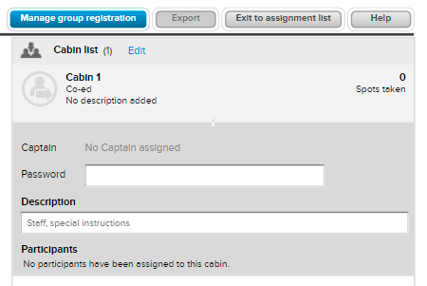

Note: Select a captain once participants are assigned.
To setup a Group Assignment click here.
Assign Participants - Now that Group Assignments are set up, assign participants
- 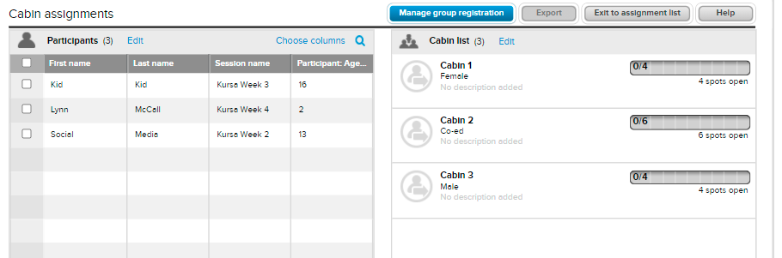

  - Click here for steps to assign participants.
  - Click here for steps to unassign a participant.

Report on Groups Assignments
Export a report of your Group Assignments.
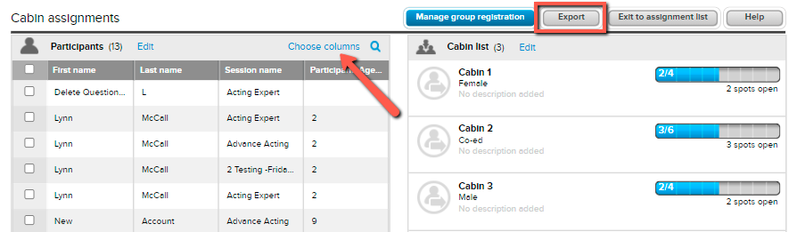
The report will include pre-selected columns listed below.
- First Name
- Last Name
- Session Name
- Participant Age as of Today
Click here for steps to edit columns in the report.

Email Group Assignments
Send communication via email to Group Assignments through a Custom Report. Follow steps below.
- From Home screen click Reports under season name
- Click New Custom Report
- Click Customize dropdown
- Select Group Records
- Select Participant: Group Assignment

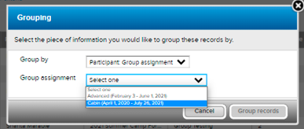
- Choose desired Group Assignment
- Click Group Records
Send an email to everyone, one group, or selected participants.
- Everyone – Check first box next to Participant Name
- Groups – Check box next to Group Name
- Participants – Individually check box next desired name
Click Email Selected People

