


Camp & Class Manager
Registration URL Links

Online Registration URL Links

Primary Registration Link
The Primary Registration Link can be linked to your organization’s website to active seasons.

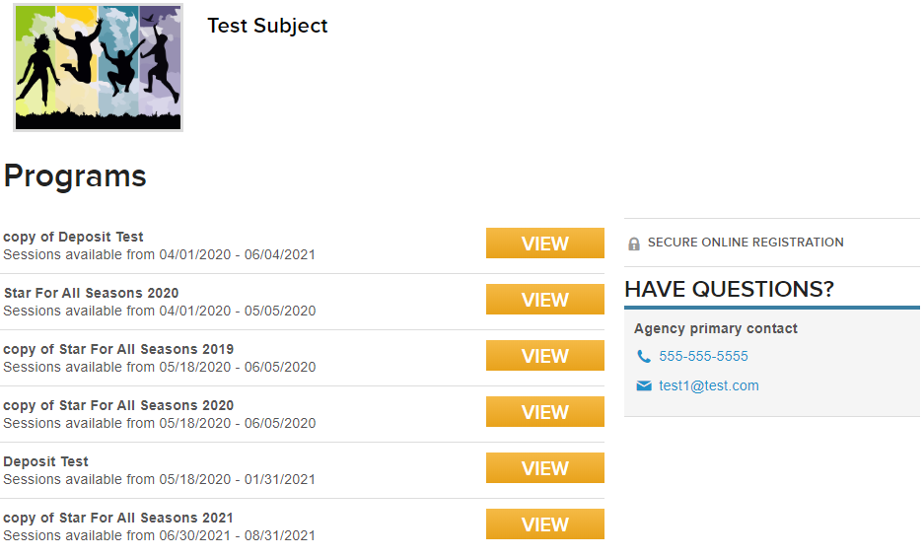
(Example list of active seasons a participant would see after accessing a Primary Registration Link.)

Locate this link on the Home screen under Quick Links.
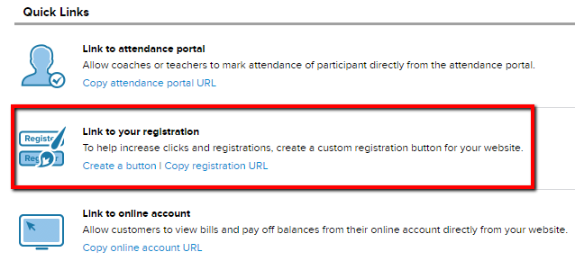
Ways to Link Participants to Registration
- Copy Registration URL Link
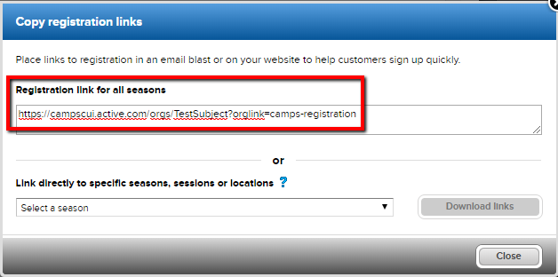
- Or Create a Button
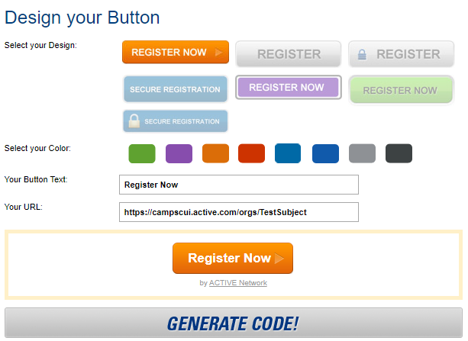
-Click here for an article with steps to create a button.

Specific Link to a Season/Location/Session or Session Type
In many situations an organization with multiple seasons and sessions may choose to direct customers to a registration form for a specific season, location, session or session type.

- Seasons - This is used when there’s multiple seasons and you want to direct participants to a specific season.
- Location - Some organizations with multiple locations want to direct participants to sessions based on where it’s located (Locations within a season).
- Sessions - This is used when you want to direct participants to a specific session.
Session Type – Each session has an option to have a Session Type assigned to it. If at least one is assigned, you can direct participants to sessions based on the assigned Session Type.
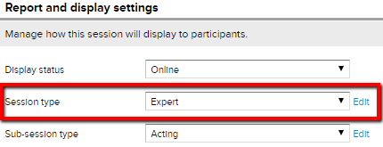
-Click here for an article on Session Type.

Below are Steps to Access Direct Links Described Above

- From Home page click Copy Registration URL
- Note: Located under Quick Links and Link to Your Registration
- Under Link Directly to a Specific Seasons select desired season from drop down options. 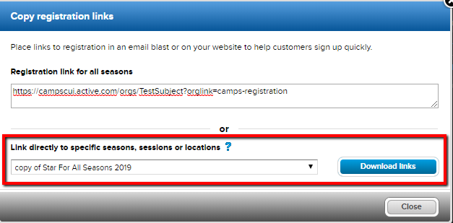
- Click Download links
- Note: An Excel Report will download to your computer.
- Open Excel Spreadsheet
- Select one of the tabs (Season/Location/Session/Session Type) at the bottom of spreadsheet
- Note: The spreadsheet should automatically open on the Season tab.
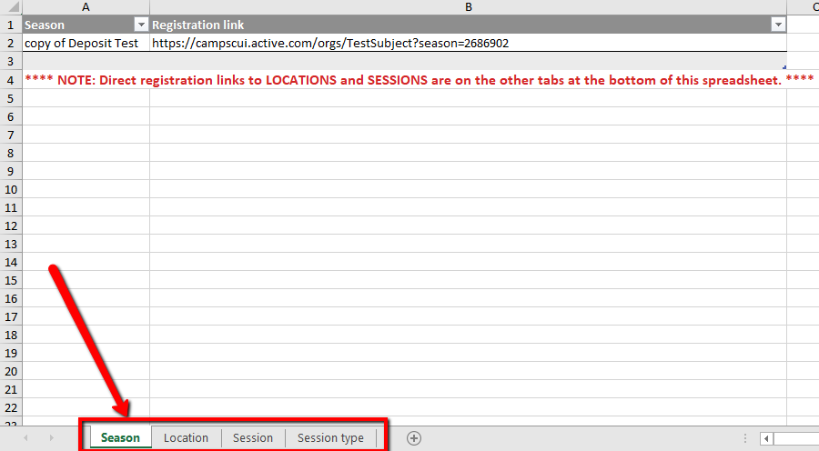
- Note: A Session Type must be assigned to at least one session for the option to display in the Excel Spreadsheet.
- Copy link listed under Registration Link
- Click here for an article in our Help Center.

Frequently Asked Questions

How do I Get a Registration Button on My Website?
Active provides the button but cannot place the button on your website. For an article with steps click here. If your button does not work contact Support.

What Link can I Share with Participants to Register?
Your primary registration link is on the Home page under Link to your Registration. Click Copy Registration URL
Choose an option for a direct link (Season/Location/Session or Session Type) or a link to all seasons.
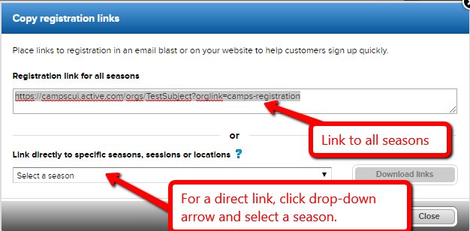

I have Multiple Tabs on My Website, and I Want to Link a Different Session to Each Tab.
Follow steps below to get direct URL links for every session.
- Select Copy Registration URL from homepage
- Select season from drop-down
- Click Download Links
- Open downloaded Excel file
- Select Session Tab from bottom of page
- Copy Registration Link for desired session
- Paste link to desired location on website

How Do I Create a Private Season or Session?
Private Season: Typically used when an organization has a priority group of participants that will register before the general public or the season will remain exclusive.
Create a private season by preventing programs from appearing on ACTIVE.com/ACTIVEkids.com, please contact support.
Note: This feature can be turned back on at any time. Programs sync to ACTIVE.com/ACTIVEkids.com every Monday. This means, if it’s turned back on a Friday, your programs won’t display until the following Monday.
Once programs have been removed, share direct season link with preferred participants.
Private Session: In order for a direct link to work for an Internal Only session(s), there must be at least one session in the same season that is displayed online. If the season doesn’t have other online sessions, consider a Donation session (This way the public doesn’t have an option to register for an actual session).
After the above criteria is met, follow the steps below to get a direct link(s) to internal session(s).
- Select Copy Registration URL from homepage
- Select a season from drop-down menu
- Click Download Links
- Open downloaded Excel file
- Select Session Tab from bottom of page
- Copy Registration Link for desired session
Note: Direct links for Season, Location and Session Type to internal sessions do not work. Session direct links only work for internal sessions.

What is The Difference Between the Registration Link & Online Account Link?
The Online Registration Link is different from the customer’s Online Account Link.
- Registration Link – Only used for online registration for existing and new registrants.
- Online Account Link – Allows customers to view bills, pay off balances, purchase available session options/merchandise and check past or current registrations. Only existing registrants can access online account.
Participants can access online registration from there online account
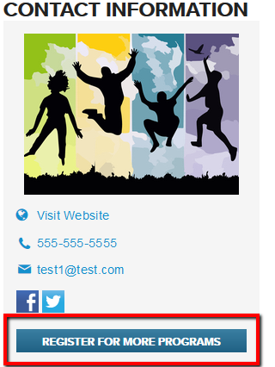
(picture of what participants see in their online account when accessing online registration)
But, cannot access their Online Account from online registration.
Online Account Link can be accessed from the participants Confirmation email under Important Links

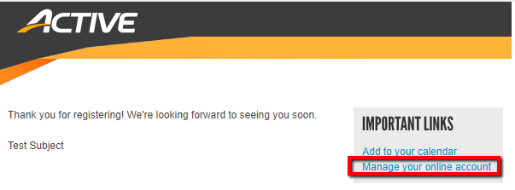
(Picture of what participants see in the confirmation email)

Or share the Online Account link with participants from Admin Database on the Home page under Link to your Registration.
