ACTIVE account statement

Purpose
The ACTIVE account statement report displays your agency's financial transactions with ACTIVE Network, including credit card/e-Check payments, refunds, payment processing fees, registration fees and past balances owed to ACTIVE. This report can be run for one or more statement/remittance periods (4 times a month, twice a month or monthly)
Location | Finance tab > Reports tab > ACTIVE account statement
Formats | MS Excel (.xlsx)

Parameters
The report output may be filtered by configuring the following parameters:
Parameter | Description
Statement time period | By default, this report includes financial transactions for the current statement period (4 times per month, twice per month or monthly) with ACTIVE Network.  To include transactions for a single or multiple remittance periods, select the required periods and then click the Update button.
For season | By default, this report includes all financial transactions (for active seasons, memberships and other) with ACTIVE Network.  To include only transactions for a specific season, membership or other, select the required item in the selected remittance periods.

Summary
Parameter | Description
Credit card activity | All credit card payments, refunds and payment processing fees in the selected remittance period and season
eCheck activity | All e-check payments, refunds, and payment processing fees in the selected remittance period and season
Registration activity | All registration fees paid by organization or consumers in the selected remittance period and season
Other | All fee adjustments, miscellaneous adjustments, fees for services, payments received, chargebacks and subscription fees in the selected remittance period and season
Total amount | Total amount owed to the agency by ACTIVE for the selected remittance period and season  Total Amount = (All Payments) - (All Refunds) - (All Fees)

Detailed Report Columns
Payment activity report
Displays tuition and membership payments by credit card or e-check during the selected remittance period, including order and allocation information.
Note: Refund transactions for cancelled purchases are displayed in this report.
Column | Description
Date | Order date
Order Number | Order number
Customer | Primary parent name or single-person account participant name
Season | Season registered
Payment method | Current supported online payment methods:  Visa, Mastercard, Amex, Discover, eCheck (ECP/EUDD/ELV)
Payment processing fee | Credit card/eCheck payment processing fee
Type | 'Payment' or 'Refund'
Amount | Total monetary amount for the order
Allocated to | Session to which the purchase is allocated

Registration activity report
Displays all registrations or orders placed for tuitions or memberships only during the selected remittance period.
Column | Description
Date | Order date
Order number | Order number
Participant | Registrant name
Season | Season registered
Session | Session or membership registered
Session Type | Session type or 'Membership' (for membership purchases)
Entry method | FDR (manual) or CUI (online) registration
Registration fee paid by organization | Registration fee paid by organization to Active for a session tuition or membership purchase.
Registration fee paid by consumer | Registration fee paid by consumer to Active for a session tuition or membership purchase.
Type | Transaction type, such as ‘Transfer in’, ‘Transfer out’ or ‘Registration’
Purchase amount | Total monetary amount of the purchase (tuition or membership)

Add-On Purchases activity
Displays all session option and merchandise purchases during the selected remittance period.
Note: Refund transactions for cancelled purchases are displayed in this report.
Column | Description
Date | Order date
Order number | Order number
Participant | Registrant
Season | Additional item season
Session | Additional item session
Session Type | Session type or 'Membership' (for membership purchases)
Item Name | Session option or merchandise name
Entry method | FDR (manual) or CUI (online) registration
Registration fee paid by organization | Registration fee paid by organization to Active for session option or merchandise purchases.
Registration fee paid by consumer | Registration fee paid by consumer to Active for session option or merchandise purchases.
Purchase amount | Total monetary amount of the purchase (option or merchandise)

Other
Displays other (Backoffice) transactions during the selected remittance period.
Column | Description
Date | Transaction date
Reason | Backoffice transaction reason: fee adjustment, miscellaneous adjustment, fees for services, payment received, chargeback or subscription fee
Description | Transaction comments
Amount | Total monetary amount transferred

Sorting
Default report sorting:
Report - Column | Order
Payment activity report – Payment date | Descending
Registration activity – Registration date | Ascending
Additional purchases activity – Registration date | Ascending

To sort by a different column, click the header of the required column:
Column type | Order | Top of report | Bottom of report
Numerical | Ascending | Smallest value | Largest value
Numerical | Descending | Largest value | Smallest value
String | Ascending | Strings beginning with 'A' | Strings beginning with 'Z'
String | Descending | Strings beginning with 'Z' | Strings beginning with 'A'
Date | Ascending | Oldest date | Latest date
Date | Descending | Latest date | Oldest date

Notes
Performance limit | n/a
Maximum record count | 100,000 records
When not to run | n/a
Report will be empty when | No payments, registrations or other transactions occurred during the selected remittance period

Example
In the following example, primary parent ‘Lily Bush’ purchased several items in a season: Dance classes with a total price of $1,120 for her child ‘George Bush’ during the selected remittance period of March 16-31, 2018, as below:
- Tuition: Ballet Tuition 1 - $1,000.00
- Session option: Ballet Bus option - $100.00
- Merchandise: Sticker - $20.00

Payment activity report record: Total payment $1,120:
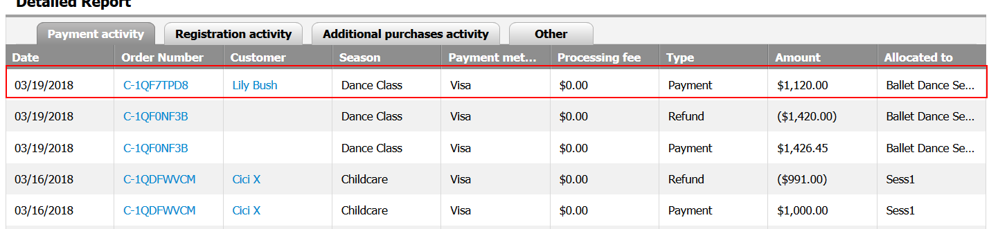

Registration activity report record: The Purchase amount of $1000 is for the tuition purchased:
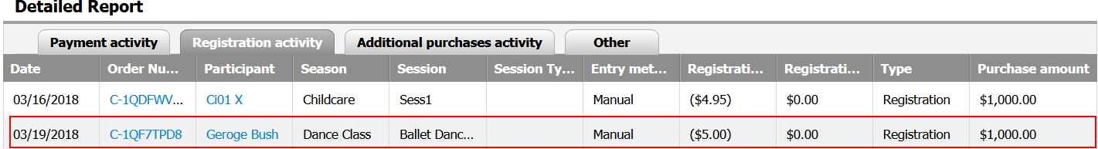
Additional purchases activity report record: Additional items (session options and merchandise) purchased are listed separately:
